Seminar paper/ Bachelor’s thesis/ Master’s thesis
for the attainment of the academic degree of
[aspired title]

Topic

Seminar paper/ Bachelor’s thesis/ Master’s thesis at the department of Environmental Economics
[Semester]

Submitted on: [Submission date]
By: [First and last name]
Matriculation No.: [Matriculation No.]
Study program: [Study program]
Supervisor: [Supervisor]

Abstract
Lorem ipsum dolor sit amet, consetetur sadipscing elitr, sed diam nonumy eirmod tempor invidunt ut labore et dolore magna aliquyam erat, sed diam voluptua. At vero eos et accusam et justo duo dolores et ea rebum. Stet clita kasd gubergren, no sea takimata sanctus est Lorem ipsum dolor sit amet. Lorem ipsum dolor sit amet, consetetur sadipscing elitr, sed diam nonumy eirmod tempor invidunt ut labore et dolore magna aliquyam erat, sed diam voluptua. At vero eos et accusam et justo duo dolores et ea rebum. Stet clita kasd gubergren, no sea takimata sanctus est Lorem ipsum dolor sit amet. Lorem ipsum dolor sit amet, consetetur sadipscing elitr, sed diam nonumy eirmod tempor invidunt ut labore et dolore magna aliquyam erat, sed diam voluptua. At vero eos et accusam et justo duo dolores et ea rebum. Stet clita kasd gubergren, no sea takimata sanctus est Lorem ipsum dolor sit amet. Duis autem vel eum iriure dolor in hendrerit in vulputate velit esse molestie consequat, vel illum dolore eu feugiat nulla facilisis at vero eros et accumsan et iusto odio dignissim qui blandit praesent luptatum zzril delenit augue duis dolore te feugait nulla facilisi.

Table of contents
Abstract I
Table of contents II
List of figures II
List of tables II
List of abbreviations II
1 The first chapter 2
1.1 A subchapter 2
1.1.1 Another section 2
1.1.2 One example image 2
1.1.3 Even more sections 2
1.2 A second subchapter 2
2 Another chapter 2
2.1 Even more subchapters 2
2.1.1 Another section 2
2.1.2 One more section 2
2.2 One last subchapter 2
Bibliography II
Appendix II
Statutory Declaration II

List of figures
Figure 1: The Economic System and the Environment 2

List of tables
Table 1: Demonstrating Present Value Calculations 2

List of abbreviations
CDM Clean Development Mechanism
FAO Food and Agriculture Organization of the United Nations
UNFCCC United Nations Framework Convention on Climate Change

The first chapter
Lorem ipsum dolor sit amet, consetetur sadipscing elitr, sed diam nonumy eirmod tempor invidunt ut labore et dolore magna aliquyam erat, sed diam voluptua. At vero eos et accusam et justo duo dolores et ea rebum. Stet clita kasd gubergren, no sea takimata sanctus est Lorem ipsum dolor sit amet.

A subchapter
Lorem ipsum dolor sit amet, consetetur sadipscing elitr, sed diam nonumy eirmod tempor invidunt ut labore et dolore magna aliquyam erat, sed diam voluptua. At vero eos et accusam et justo duo dolores et ea rebum. Stet clita kasd gubergren, no sea takimata sanctus est Lorem ipsum dolor sit amet.

Another section
Lorem ipsum dolor sit amet, consetetur sadipscing elitr, sed diam nonumy eirmod tempor invidunt ut labore et dolore magna aliquyam erat, sed diam voluptua. At vero eos et accusam et justo duo dolores et ea rebum. Stet clita kasd gubergren, no sea takimata sanctus est Lorem ipsum dolor sit amet.
Lorem ipsum dolor sit amet, consetetur sadipscing elitr, sed diam nonumy eirmod tempor invidunt ut labore et dolore magna aliquyam erat, sed diam voluptua. At vero eos et accusam et justo duo dolores et ea rebum. Stet clita kasd gubergren, no sea takimata sanctus est Lorem ipsum dolor sit amet. Lorem ipsum dolor sit amet, consetetur sadipscing elitr, sed diam nonumy eirmod tempor invidunt ut labore et dolore magna aliquyam erat, sed diam voluptua. At vero eos et accusam et justo duo dolores et ea rebum. Stet clita kasd gubergren, no sea takimata sanctus est Lorem ipsum dolor sit amet. Lorem ipsum dolor sit amet, consetetur sadipscing elitr, sed diam nonumy eirmod tempor invidunt ut labore et dolore magna aliquyam erat, sed diam voluptua. At vero eos et accusam et justo duo dolores et ea rebum. Stet clita kasd gubergren, no sea takimata sanctus est Lorem ipsum dolor sit amet.
Duis autem vel eum iriure dolor in hendrerit in vulputate velit esse molestie consequat, vel illum dolore eu feugiat nulla facilisis at vero eros et accumsan et iusto odio dignissim qui blandit praesent luptatum zzril delenit augue duis dolore te feugait nulla facilisi. Lorem ipsum dolor sit amet, consectetuer adipiscing elit, sed diam nonummy nibh euismod tincidunt ut laoreet dolore magna aliquam erat volutpat.
Ut wisi enim ad minim veniam, quis nostrud exerci tation ullamcorper suscipit lobortis nisl ut aliquip ex ea commodo consequat. Duis autem vel eum iriure dolor in hendrerit in vulputate velit esse molestie consequat, vel illum dolore eu feugiat nulla facilisis at vero eros et accumsan et iusto odio dignissim qui blandit praesent luptatum zzril delenit augue duis dolore te feugait nulla facilisi.

One example image
Lorem ipsum dolor sit amet, consetetur sadipscing elitr, sed diam nonumy eirmod tempor invidunt ut labore et dolore magna aliquyam erat, sed diam voluptua. At vero eos et accusam et justo duo dolores et ea rebum. Stet clita kasd gubergren, no sea takimata sanctus est Lorem ipsum dolor sit amet.

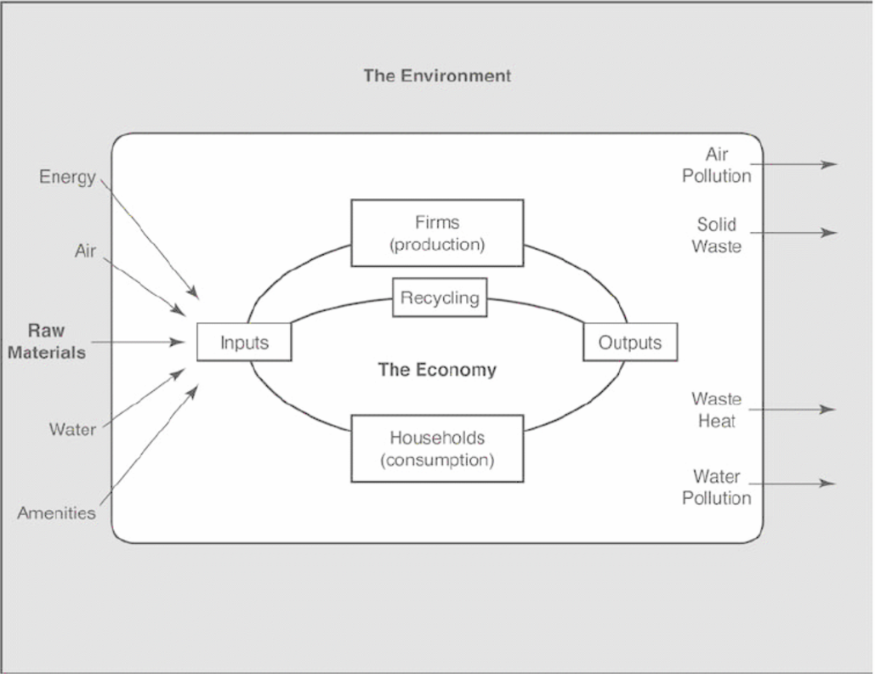
Figure 1: The Economic System and the Environment
(Source: Tietenberg, Lewis 2018, 18)

Lorem ipsum dolor sit amet, consetetur sadipscing elitr, sed diam nonumy eirmod tempor invidunt ut labore et dolore magna aliquyam erat, sed diam voluptua. At vero eos et accusam et justo duo dolores et ea rebum. Stet clita kasd gubergren, no sea takimata sanctus est Lorem ipsum dolor sit amet.

Even more sections
Lorem ipsum dolor sit amet, consetetur sadipscing elitr, sed diam nonumy eirmod tempor invidunt ut labore et dolore magna aliquyam erat, sed diam voluptua. At vero eos et accusam et justo duo dolores et ea rebum. Stet clita kasd gubergren, no sea takimata sanctus est Lorem ipsum dolor sit amet. Lorem ipsum dolor sit amet, consetetur sadipscing elitr, sed diam nonumy eirmod tempor invidunt ut labore et dolore magna aliquyam erat, sed diam voluptua. At vero eos et accusam et justo duo dolores et ea rebum. Stet clita kasd gubergren, no sea takimata sanctus est Lorem ipsum dolor sit amet. Lorem ipsum dolor sit amet, consetetur sadipscing elitr, sed diam nonumy eirmod tempor invidunt ut labore et dolore magna aliquyam erat, sed diam voluptua. At vero eos et accusam et justo duo dolores et ea rebum. Stet clita kasd gubergren, no sea takimata sanctus est Lorem ipsum dolor sit amet.
Duis autem vel eum iriure dolor in hendrerit in vulputate velit esse molestie consequat, vel illum dolore eu feugiat nulla facilisis at vero eros et accumsan et iusto odio dignissim qui blandit praesent luptatum zzril delenit augue duis dolore te feugait nulla facilisi. Lorem ipsum dolor sit amet, consectetuer adipiscing elit, sed diam nonummy nibh euismod tincidunt ut laoreet dolore magna aliquam erat volutpat.

A second subchapter
Lorem ipsum dolor sit amet, consetetur sadipscing elitr, sed diam nonumy eirmod tempor invidunt ut labore et dolore magna aliquyam erat, sed diam voluptua. At vero eos et accusam et justo duo dolores et ea rebum. Stet clita kasd gubergren, no sea takimata sanctus est Lorem ipsum dolor sit amet.

Another chapter
Lorem ipsum dolor sit amet, consetetur sadipscing elitr, sed diam nonumy eirmod tempor invidunt ut labore et dolore magna aliquyam erat, sed diam voluptua. At vero eos et accusam et justo duo dolores et ea rebum. Stet clita kasd gubergren, no sea takimata sanctus est Lorem ipsum dolor sit amet.

Even more subchapters
Lorem ipsum dolor sit amet, consetetur sadipscing elitr, sed diam nonumy eirmod tempor invidunt ut labore et dolore magna aliquyam erat, sed diam voluptua. At vero eos et accusam et justo duo dolores et ea rebum. Stet clita kasd gubergren, no sea takimata sanctus est Lorem ipsum dolor sit amet.

Another section
Lorem ipsum dolor sit amet, consetetur sadipscing elitr, sed diam nonumy eirmod tempor invidunt ut labore et dolore magna aliquyam erat, sed diam voluptua. At vero eos et accusam et justo duo dolores et ea rebum. Stet clita kasd gubergren, no sea takimata sanctus est Lorem ipsum dolor sit amet.
Lorem ipsum dolor sit amet, consetetur sadipscing elitr, sed diam nonumy eirmod tempor invidunt ut labore et dolore magna aliquyam erat, sed diam voluptua. At vero eos et accusam et justo duo dolores et ea rebum. Stet clita kasd gubergren, no sea takimata sanctus est Lorem ipsum dolor sit amet. Lorem ipsum dolor sit amet, consetetur sadipscing elitr, sed diam nonumy eirmod tempor invidunt ut labore et dolore magna aliquyam erat, sed diam voluptua. At vero eos et accusam et justo duo dolores et ea rebum. Stet clita kasd gubergren, no sea takimata sanctus est Lorem ipsum dolor sit amet. Lorem ipsum dolor sit amet, consetetur sadipscing elitr, sed diam nonumy eirmod tempor invidunt ut labore et dolore magna aliquyam erat, sed diam voluptua. At vero eos et accusam et justo duo dolores et ea rebum. Stet clita kasd gubergren, no sea takimata sanctus est Lorem ipsum dolor sit amet.
Duis autem vel eum iriure dolor in hendrerit in vulputate velit esse molestie consequat, vel illum dolore eu feugiat nulla facilisis at vero eros et accumsan et iusto odio dignissim qui blandit raesent luptatum zzril delenit augue duis dolore te feugait nulla facilisi. Lorem ipsum dolor sit amet, consectetuer adipiscing elit, sed diam nonummy nibh euismod tincidunt ut laoreet dolore magna aliquam erat volutpat.

Table 1: Demonstrating Present Value Calculations
(Source: Tietenberg, Lewis 2018, 50)
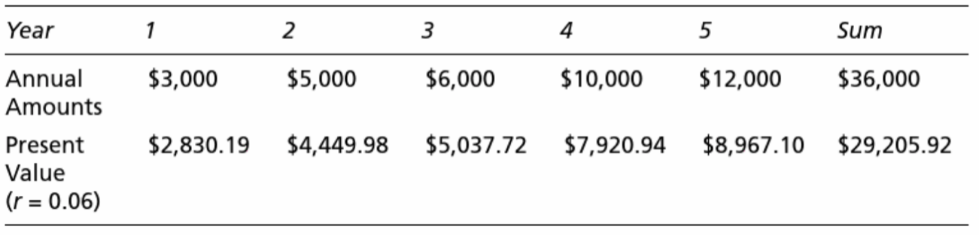

Lorem ipsum dolor sit amet, consetetur sadipscing elitr, sed diam nonumy eirmod tempor invidunt ut labore et dolore magna aliquyam erat, sed diam voluptua. At vero eos et accusam et justo duo dolores et ea rebum. Stet clita kasd gubergren, no sea takimata sanctus est Lorem ipsum dolor sit amet. Lorem ipsum dolor sit amet, consetetur sadipscing elitr, sed diam nonumy eirmod tempor invidunt ut labore et dolore magna aliquyam erat, sed diam voluptua. At vero eos et accusam et justo duo dolores et ea rebum. Stet clita kasd gubergren, no sea takimata sanctus est Lorem ipsum dolor sit amet. Lorem ipsum dolor sit amet, consetetur sadipscing elitr, sed diam nonumy eirmod tempor invidunt ut labore et dolore magna aliquyam erat, sed diam voluptua. At vero eos et accusam et justo duo dolores et ea rebum. Stet clita kasd gubergren, no sea takimata sanctus est Lorem ipsum dolor sit amet.

One more section
Lorem ipsum dolor sit amet, consetetur sadipscing elitr, sed diam nonumy eirmod tempor invidunt ut labore et dolore magna aliquyam erat, sed diam voluptua. At vero eos et accusam et justo duo dolores et ea rebum. Stet clita kasd gubergren, no sea takimata sanctus est Lorem ipsum dolor sit amet.

One last subchapter
Lorem ipsum dolor sit amet, consetetur sadipscing elitr, sed diam nonumy eirmod tempor invidunt ut labore et dolore magna aliquyam erat, sed diam voluptua. At vero eos et accusam et justo duo dolores et ea rebum. Stet clita kasd gubergren, no sea takimata sanctus est Lorem ipsum dolor sit amet.

Bibliography
References to other publications should follow the "Chicago Author Date" style and be carefully checked for completeness, accuracy, and consistency. A bibliography should be provided at the end of the paper in alphabetical order.

For books:
Bicchieri, Cristina. 2017. Norms in the Wild: How to Diagnose, Measure, and Change Social Norms. New York, NY: Oxford University Press. https://doi.org/10.1093/acprof:oso/9780190622046.001.0001.

For book chapters:
Dietz, Simon, and Eric Neumayer. 2006. ‘A Critical Appraisal of Genuine Savings as an Indicator of Sustainability’. In Sustainable Development Indicators in Ecological Economics, edited by Philip Lawn, 117–35. Edward Elgar Publishing. https://doi.org/10.4337/9781845428952.00012.

For journal articles:
Gächter, Simon, Leonie Gerhards, and Daniele Nosenzo. 2017. ‘The Importance of Peers for Compliance with Norms of Fair Sharing’. European Economic Review 97 (August): 72–86. https://doi.org/10.1016/j.euroecorev.2017.06.001.

For working papers:
List, John. 2020. ‘Non Est Disputandum de Generalizability? A Glimpse into The External Validity Trial’. 27535. NBER Working Paper. Cambridge, MA: National Bureau of Economic Research. https://doi.org/10.3386/w27535.

For internet sources:
University of Osnabrück. 2020. “Volkswirtschaftslehre (Economics) - Master of Science.” Accessed September 24, 2020. https://www.uni-osnabrueck.de/studieninteressierte/studiengaenge_a_z/volkswirtschaftslehre_economics_master_of_science.html.

Appendix
Appendix A
Insert Appendix A here. The next appendix is inserted on the following page for the sake of clarity.
Appendix B
Insert Appendix B here and so on.

Statutory Declaration
I hereby confirm that I have written the present thesis - in the case of group work, my marked share - independently and without the use of any source and aid other than stated. Verbatim sentences or parts of sentences are marked as a quotation, other allusions, in terms of statement and scope, are marked with a reference to the source. I have taken notice of the regulations on cheating in the examination regulations.

The thesis has not been submitted to any examination authority in the same or a similar form and has not been published. It has not been used, not even in part, for any other examination or course work.

In the case of written work which must be submitted additionally in electronic form, the following sentence must be added:

The hardcopy versions of this thesis are identical in content to the submitted electronic version.

Place, Date: …………………..…… Signature: ………………………..…….

An example of a footnote.

